**Project Progress 1**

โมกข์ มาอาจ 65-040626-2015-9

อธิชา เล็กสรรเสริญ 65-040626-2017-5

**Containers**

**history.csv**: เก็บข้อมูลประวัติการเล่น

* date: เวลาที่เกมนั่นจบลง (Epoch time)
* target_word: คำตอบของเกมนั่น
* guess_count: จำนวนที่ผู้เล่นตอบ (-1 ถ้าแพ้)
* guess_word1 - guess_word6: คำที่ผู้เล่นเดา

ข้อมูลตัวอย่าง:

|  |
| --- |
| 1665291629.7163048,fells,6,crane,epoxy,bezel,devil,jewel,fells  1665291684.4712517,jacks,3,crane,wacky,jacks,,,  1665291827.2184944,twats,-1,crane,plaza,quash,staff,toast,staid |

* **entryList**: ไว้เก็บ Entry ที่เป็นตารางการเล่น (5 x 6) สำหรับแก้ไขสี

ข้อมูลตัวอย่าง: entryList = [

[<tkinter.Entry object .!frame29.!entry>, …], # ขนาด 5

[<tkinter.Entry object .!frame29.!entry>, …], # ขนาด 5

…

] # ขนาด 6

* **buttonList**: ไว้เก็บ Button ที่เป็นคีย์บอร์ดสำหรับแก้ไขสี (เก็บตามตัวอักษร)

ข้อมูลตัวอย่าง: buttonList = {

'q': <tkinter.Button object .!frame.!button2>,

'w': <tkinter.Button object .!frame2.!button2>,

…

}

* **textVariableList**: เหมือนกับ entryList แต่เก็บ textVariable แทนไว้ใช้เปลี่ยนค่าที่แสดงอยู่
* **wordsList**: ไว้เก็บคําศัพท์ของ Wordle ทั้งหมด (เปิดมาจากไฟล์)
* **guessList**: ไว้เก็บคำที่ผู้เล่นเดา ในเกมนั่นๆ (รีเซ็ตทุกๆ เกม)

ข้อมูลตัวอย่าง: guessList = [‘crane’, ‘plaza’, ‘quash’, ‘staff’, ‘toast’, ‘staid’]

* **targetWordCount**: จำนวนของแต่ละตัวอักษรของคำตอบ (รีเซ็ตทุกๆ เกม)

ข้อมูลตัวอย่าง: ถ้าคำตอบ = ‘fells’, targetWordCount = {

‘f’: 1, ‘e’: 1, ‘l’: 2, ‘s’: 1

}

* **currWordState**: ไว้เก็บข้อมูล (ว่าเป็นสีเหลือง หรือเขียว) ของคำที่ผู้เล่นเดา (รีเซ็ตทุกๆ ครั้งที่ผู้เล่นพิมพ์)

ข้อมูลตัวอย่าง: ถ้าคำตอบ = ‘wonts’, ผู้เล่นเดาว่า ‘pains’, จะได้ currWordState = {

0: {'char': 'p', 'color': 'gray'},

1: {'char': 'a', 'color': 'gray'},

2: {'char': 'i', 'color': 'gray'},

3: {'char': 'n', 'color': 'yellow'},

4: {'char': 's', 'color': 'green'}

}

**GUI** (Graphics & Coding)

* หน้า GUI ระหว่างเล่น (ชนะ / แพ้)

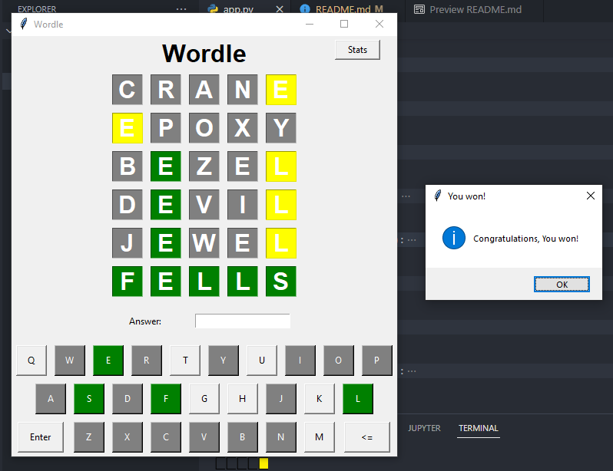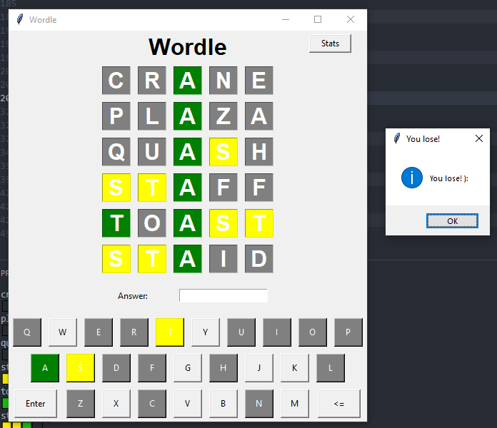

* หน้า GUI ของ Stats & History
* หน้า GUI ของ stats & History

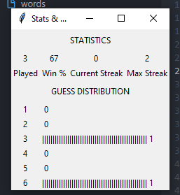

**Program** (Python Coding)

from math import floor

from tkinter import *

from tkinter import messagebox

import random

import time

import csv

# Global Game Variable

entryList = []          # Store all Entry

buttonList = {}         # Store all Keyboard's Button

textVariableList = []   # Store all Entry's TextVariable

wordsList = []          # Wordle's words list

answerEntry = None      # Answer Entry box

answerVariable = None   # Answer Entry box's TextVariable

guessList = []          # Current Game's guess words

targetWord = ''         # Current Game's target word

currRow = 0             # Current Game's playing row

# Constants

HISTORY_HEADER = [

    'date',

    'target_word',

    'guess_count',

    'guess_word1',

    'guess_word2',

    'guess_word3',

    'guess_word4',

    'guess_word5',

    'guess_word6'

]

def getHistory():

    try:

        f = open('history.csv', 'r+', newline='')

    except:

        try:

            # File does not existed

            f = open('history.csv', 'w+', newline='')

        except:

            print('Error can\'t create history.csv File, getHistory()')

            return []

    csvReader = csv.reader(f)

    historyData = [row for row in csvReader]

    # File existed, but it's empty

    if len(historyData) == 0:

        csvWriter = csv.writer(f)

        csvWriter.writerow(HISTORY_HEADER)

    else:

        # Removed first row (header row)

        historyData = historyData[1:]

    f.close()

    return historyData

def updateHistory(data):

    if(len(data) != len(HISTORY_HEADER)):

        print('Invalid History data!, (updateHistory(data))')

        return False

    # Call for header checking ...

    getHistory()

    try:

        f = open('history.csv', 'a', newline='')

    except:

        print('Error can\'t open history.csv File')

        return False

    csvWriter = csv.writer(f)

    csvWriter.writerow(data)

    f.close()

    return True

def drawButton(text='', row=0, rowspan=1, column=0, columnspan=1, width=100, height=100, command=None, keyboard=False):

    frame = Frame(root, width=width, height=height)

    button = Button(frame, text=text, command=command)

    if(keyboard):

        button = Button(frame, text=text,

                        command=lambda: onKeyboardClick(text))

    frame.grid_propagate(False)         # Disables resizing of frame

    frame.columnconfigure(0, weight=1)  # Enables button to fill frame

    frame.rowconfigure(0, weight=1)

    frame.grid(row=row, column=column, rowspan=rowspan,

               columnspan=columnspan, padx=5, pady=5)

    button.grid(sticky='wens')

    return button

def drawSquareEntry(textvariable, row=0, rowspan=1, column=0, columnspan=1, width=100, height=100):

    frame = Frame(root, width=width, height=height)

    entry = Entry(frame, textvariable=textvariable, justify='center',

                  foreground='white', font='Helvetica 24 bold')

    frame.grid_propagate(False)         # Disables resizing of frame

    frame.columnconfigure(0, weight=1)  # Enables button to fill frame

    frame.rowconfigure(0, weight=1)

    frame.grid(row=row, column=column, rowspan=rowspan,

               columnspan=columnspan, padx=5, pady=5)

    entry.grid(sticky='wens')

    return entry

def initKeyboardGUI():

    keyboardLayout = [

        'QWERTYUIOP',

        'ASDFGHJKL',

        'ZXCVBNM'

    ]

    offset = [0, 1, 3]

    startRow, startColumn = 19, 1

    # Draw Keyboard Key

    for inxRow, row in enumerate(keyboardLayout):

        placeRow = startRow + (2 * inxRow)

        for inxCol, text in enumerate(list(row)):

            placeColumn = startColumn + (2 * inxCol) + offset[inxRow]

            btn = drawButton(text, width=40, height=40,

                             row=placeRow, rowspan=2,

                             column=placeColumn, columnspan=2, keyboard=True

                             )

            buttonList[text.lower()] = btn

    # Enter Button

    drawButton('Enter', row=23, rowspan=2, column=1,

               columnspan=3, width=40 / 2 * 3, height=40, command=checkWord)

    # Return Button

    drawButton('<=', row=23, rowspan=2, column=18,

               columnspan=3, width=40 / 2 * 3, height=40, command=onReturn)

def initDisplay():

    startRow, startColumn = 4, 6

    # Display 6 x 5

    for inxRow in range(6):

        placeRow = startRow + (2 * inxRow)

        textVariableRow = []

        entryRow = []

        for inxCol in range(5):

            placeColumn = startColumn + (2 * inxCol)

            str = StringVar()

            textVariableRow.append(str)

            entry = drawSquareEntry(str,  width=40, height=40,

                                    row=placeRow, rowspan=2,

                                    column=placeColumn, columnspan=2

                                    )

            entry['state'] = DISABLED

            entry['disabledbackground'] = 'white'

            entry['disabledforeground'] = 'white'

            entryRow.append(entry)

        textVariableList.append(textVariableRow)

        entryList.append(entryRow)

    # Answer Box

    Label(root, text='Answer: ').grid(

        row=17, column=6, columnspan=4, pady=15)

    global answerVariable

    answerVariable = StringVar()

    entryAnswer = Entry(root, textvariable=answerVariable)

    entryAnswer.grid(row=17, column=10, columnspan=6, pady=15)

    entryAnswer.bind('<Return>', checkWord)

    entryAnswer.focus()

    global answerEntry

    answerEntry = entryAnswer

def onReturn():

    currWord = answerVariable.get()

    currWord = currWord[:-1]  # Remove last element

    answerVariable.set(currWord)

    answerEntry.icursor(len(currWord))

def onKeyboardClick(key):

    currWord = answerVariable.get()

    currWord += key.lower()

    answerVariable.set(currWord)

    answerEntry.icursor(len(currWord))

def checkWord(event=None):

    currWord = answerVariable.get().strip().lower()

    # Is word empty

    if(len(currWord) == 0):

        messagebox.showinfo('Please enter again', 'Word can\'t be emptied!')

        return

    # Is word wrong size

    if(len(currWord) != 5):

        messagebox.showinfo('Please enter again', 'Word size must be 5!')

        return

    # Is word a word

    if(currWord not in wordsList):

        messagebox.showinfo('Please enter again', 'Not in word list!')

        return

    print(currWord, targetWord)

    guessList.append(currWord)

    # Create dict of each letter count of Target Word

    targetWordCount = {}

    for c in targetWord:

        if(c in targetWordCount):

            targetWordCount[c] += 1

        else:

            targetWordCount[c] = 1

    currWordState = {}

    # Check for exact match

    for idx, char in enumerate(currWord):

        if(char == targetWord[idx]):

            # Remove Exact Match from Target Word's letter count

            targetWordCount[char] -= 1

            # Exact Match, green color

            currWordState[idx] = {

                'char': char,

                'color': 'green'

            }

        else:

            # Not Exact Match, can be yellow, or gray

            currWordState[idx] = {

                'char': char,

                'color': 'gray'

            }

    for idx, char in enumerate(currWord):

        # Is there is any char in Target Word

        if(char in targetWord):

            if(targetWordCount[char] != 0):

                # If not Exact Match but exist in word, yellow color

                if(currWordState[idx]['color'] != 'green'):

                    currWordState[idx]['color'] = 'yellow'

                    targetWordCount[char] -= 1

                # No more words left, gray color

                elif(targetWordCount[char] < 1):

                    currWordState[idx]['color'] = 'gray'

    global currRow

    # Set Color, and Char

    for idx in currWordState:

        if(currWordState[idx]['color'] == 'green'):

            print('🟩', end='')

        elif(currWordState[idx]['color'] == 'yellow'):

            print('🟨', end='')

        elif(currWordState[idx]['color'] == 'gray'):

            print('⬛', end='')

        textVariableList[currRow][idx].set(currWordState[idx]['char'].upper())

        # entryList[currRow][idx]['background'] = currWordState[idx]['color']

        entryList[currRow][idx]['disabledbackground'] = currWordState[idx]['color']

        entryList[currRow][idx]['state'] = DISABLED

        buttonList[currWordState[idx]['char']

                   ]['background'] = currWordState[idx]['color']

        buttonList[currWordState[idx]['char']]['foreground'] = 'white'

    print('')

    answerVariable.set('')

    currRow += 1

    # Answer is correct

    if(currWord == targetWord):

        messagebox.showinfo('You won!', 'Congratulations, You won!')

        history = [

            time.time(),  # date

            targetWord,   # target_word

            currRow,      # guess_count

        ]

        # guess_word1 - guess_word6

        for i in range(6):

            if(i >= len(guessList)):

                history.append('')

            else:

                history.append(guessList[i])

        print(history)

        updateHistory(history)

        gameCycle()

        return

    # You lose ):

    if(currRow == 6):

        messagebox.showinfo('You lose!', 'You lose! ):')

        history = [

            time.time(),   # date

            targetWord,    # target_word

            -1,            # guess_count,

            guessList[0],  # guess_word1

            guessList[1],  # guess_word2

            guessList[2],  # guess_word3

            guessList[3],  # guess_word4

            guessList[4],  # guess_word5

            guessList[5],  # guess_word6

        ]

        updateHistory(history)

        gameCycle()

        return

def gameCycle():

    # Pick random words

    # random.seed('Can I get A dai mai, Ajarn')  # Just for testing

    global targetWord

    targetWord = random.choice(wordsList)

    global guessList

    guessList = []

    # Reset Counter

    global currRow

    currRow = 0

    for idxRow, row in enumerate(textVariableList):

        for idxCol, textVar in enumerate(row):

            textVar.set('')

            entryList[idxRow][idxCol]['disabledbackground'] = 'white'

    for btn in buttonList:

        # Default Button Color

        buttonList[btn]['background'] = 'SystemButtonFace'

        buttonList[btn]['foreground'] = 'black'

def StatsWindow():

    root2 = Tk()

    root2.title('Stats & History | Wordle')

    historyData = getHistory()

    # print(len(historyData))              # For testing

    # [print(row) for row in historyData]  # For testing

    # One loop calculate all

    winCount = 0

    winGuessCount = {

        '1': 0,

        '2': 0,

        '3': 0,

        '4': 0,

        '5': 0,

        '6': 0

    }

    highestStreak = 0

    currStreak = 0

    for game in historyData:

        guessCount = int(game[2])

        # Winning

        if(guessCount != -1):

            winGuessCount[str(guessCount)] += 1

            winCount += 1

            currStreak += 1

        else:  # Losing

            if(currStreak > highestStreak):

                highestStreak = currStreak

            currStreak = 0

    # Draw 'STATISTICS' Label

    Label(root2, text='STATISTICS').grid(row=0, column=0, columnspan=4, pady=5)

    # Draw Play count

    playCount = len(historyData)

    Label(root2, text=playCount).grid(row=1, column=0)

    Label(root2, text='Played').grid(row=2, column=0)

    # Draw Win rate

    winRate = winCount / playCount

    Label(root2, text=str(round(winRate * 100))).grid(row=1, column=1)

    Label(root2, text='Win %').grid(row=2, column=1)

    # Draw Current Streak

    Label(root2, text=str(currStreak)).grid(row=1, column=2)

    Label(root2, text='Current Streak').grid(row=2, column=2)

    # Draw Max Streak

    Label(root2, text=str(highestStreak)).grid(row=1, column=3)

    Label(root2, text='Max Streak').grid(row=2, column=3)

    # Draw 'GUESS DISTRIBUTION' Label

    Label(root2, text='GUESS DISTRIBUTION').grid(

        row=3, column=0, columnspan=4, pady=5)

    maxLength = max([winGuessCount[key] for key in winGuessCount])

    charType, charMaxSize = '|', 50

    for i in winGuessCount:

        graphBar = charType * floor(charMaxSize * winGuessCount[i] / maxLength)

        idx = int(i) - 1

        Label(root2, text=i).grid(row=4+idx, column=0)

        Label(root2, text=f'{graphBar} {winGuessCount[i]}').grid(

            row=4+idx, column=1, columnspan=3, sticky='W')

    f.close()

    root2.mainloop()

if __name__ == '__main__':

    root = Tk()

    root.title('Wordle')

    root.rowconfigure(tuple(range(22)), weight=1, minsize=1)

    root.columnconfigure(tuple(range(22)), weight=1, minsize=1)

    # Draw Title

    Label(root, text='Wordle', font='Helvetica 24 bold').grid(

        row=1, column=8, rowspan=2, columnspan=6)

    # Stats Button

    Button(root, text='Stats', width=7, command=StatsWindow).grid(

        row=1, column=17, columnspan=4)

    # Draw Components

    initKeyboardGUI()

    initDisplay()

    # Load Words List

    try:

        f = open('words', 'r')

        wordsList = f.read().split('\n')

        f.close()

    except:

        print('Can\'t Find Words list File, exiting...')

        exit()

    print(f'Loaded {len(wordsList)} words')

    # Main Game Cycle

    gameCycle()

    root.mainloop()

**Flow Chart**



